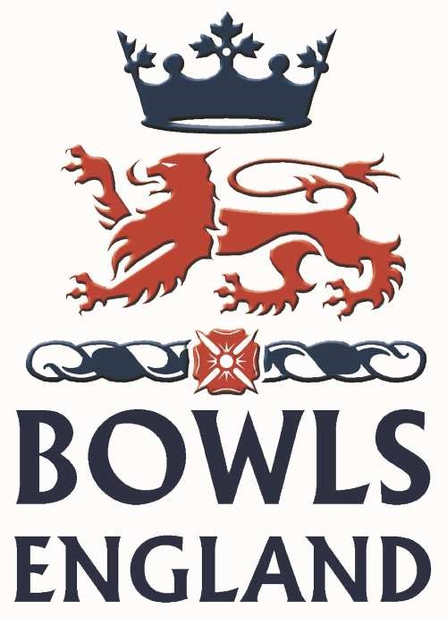
Coloured Clothing

Guidance for
Clubs

Bowls England has given approval for coloured shirts to be worn by clubs provided that a County is in agreement that coloured shirts will be permitted for clubs under their jurisdiction.

All club coloured shirts shall be registered and approved by your County Association to which this completed form should be sent. Bowls England does not approve Club Coloured clothing. If a club wishes to play in coloured shirts then it is an expectation that ALL participants must wear the same matching design, except by prior local agreement between the participating clubs or the organising body (i.e. County Association).

Should an event be sponsored, any other logos depicting other sponsors will not be permitted to be worn, unless approved by the event sponsor.

Basic Guidelines:

- The shirt shall have a collar.

- The shirt can be long or short sleeved.

- Any logo, wording, picture or any other form of reproduction associated with the business or name of a sponsor, or a Club badge, should be clearly shown on the diagram of the shirt submitted for approval.

It is recognised that Clubs may also have coloured jumpers, fleeces, windcheaters and waterproofs. These may not always be exactly the same colour/design as the shirts so it would be helpful if you could indicate this on the registration form.

- The name of the Club may be printed on the back of the shirt at shoulder blade level in lettering of not more than 40mm in height. Only one horizontal line of letters may be used.

- A shirt manufacturer’s name tag may be permitted provided that it is of an area not greater than 10 sq cm.

To register the design and colour of the shirts and to obtain County Association approval, please complete the form overleaf. Any changes to a registered and approved coloured shirt will require written approval from your County Association.

Clubs are asked to complete a separate form for each individual shirt design.

Coloured Clothing

Registration form for
Clubs

Name of Secretary:

Club:

I wish to apply for approval of the following design and colour of the shirts to be worn by players representing .

Club colours are:

Bowls disc colours:

The colour(s) of the shirt will be:

The colour(s) of the collar will be:

The colour(s) of the cuffs will be:

The colour(s) of the sleeves will be:

Other coloured clothing: ___ ____________________ _

____

Logos, badges and wording as indicated in the sketch on following page.

I certify that if lettering of the Club is to be used on the back of the shirt there shall only be one horizontal line and the letters will not exceed 40mm in height.

When the design and colour(s) have been registered, no changes will be made to the design without the written approval of the County Association.

Signed:

Club:

Date:

Coloured Clothing

Registration form for
Clubs

Please complete the sketch below in colour where possible indicating the colours to be used, the location of any badges/logos/wording and indicating/shading side panels if appropriate

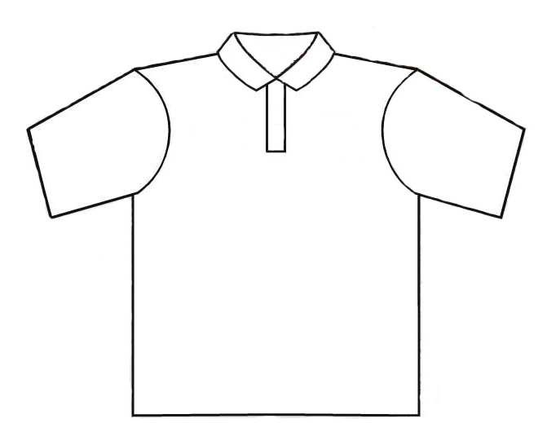
FRONT OF SHIRT

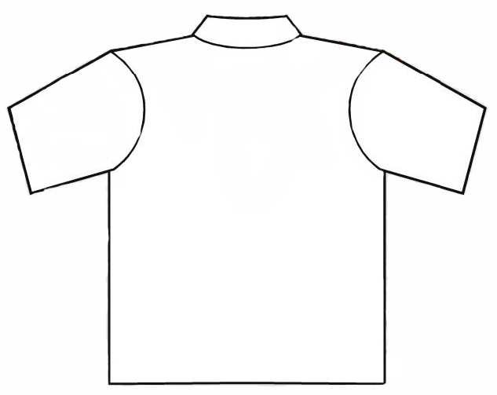 BACK OF SHIRT

County approved
(A copy will be returned to the Club for record purposes)

Signed:
Position:

Date:

